Draft Position Paper
Long-term evolution of Network Management

The ICB has been tasked by the Commission to provide advice on the long-term (10-15 year) evolution of network management and implications for the future Network Manager, following a scenario-based approach. The deadline for delivery of advice to the Commission is Q2 2016.
The ISG has so far held a number of working sessions at ISG/60, 62 and 63. The ICB has also provided strategic direction on the topic through sessions at ICB/57, and 58 in addition to a separate 2 day ICB workshop held in January 2016.
A strawman discussion paper based on analysis of the work completed to-date was discussed at ICB/59 to scope the deliverable to the Commission. From this basis, an outline draft position paper was subsequently developed for advancement and discussion at ISG/64.
This paper contains the additions and revisions as agreed at ISG/64.

context
The current EUROCONTROL designation as Network Manager runs until the end of RP2 (end of 2019). The future of network management is under review by the European Commission:
- the Network Functions Implementing Regulation (NF IR) (677/2011) is in the second phase of a two-step review and update process.
- the Commission has procured a study and review of the Network Manager, which is due to report in May 2016.
The ICB recognises the coordination of network functions through a Network Manager, to ensure optimised use of resources, as a crucial part of realising the ICB’s vision for SES. Through consideration of the long-term evolution of network management, the ICB supports the review of network management, providing recommendations to support the update of the Network Functions IR.
This draft position paper contains the revisions and additions agreed at ISG/64. The ISG is asked to review the updated paper ahead of ICB/60.

evolution of the european atm network
Whichever direction the European ATM network evolves; the Network Manager must support future optimisation of the network to meet the performance requirements of all stakeholders. With the Single European Sky (SES) at a critical point in its implementation, the European ATM network could fundamentally change shape over the next decade or so.
The ICB believes that the European ATM network covers in its broadest sense – services and data exchange; stakeholders and their interactions; infrastructure and architecture within the core 28+2 EU Member States.
The ICB considers the following factors to be relatively ‘certain’ about the European ATM network to 2030:

- Safety will remain at the forefront of all aviation activities and change programmes.
- National security (including cyber security) and the need to support shared use of airspace will remain an important aspect of the network.
- EU-wide decisions about the network will need to be made to optimise network-wide performance.
- Interoperability with neighbouring countries (ie those surrounding Europe), and knowledge of traffic from neighbouring regions and global traffic patterns, will be essential.
- Technical solutions will be made available to support the realisation of the ATM Master Plan – but how these technologies are leveraged in support of the network is not yet certain.
- There will be high variation in local demand – for example due to business priorities of AUs, weather events, changing environment, geo-political and economic events.
- A flexible network to meet varying demand is essential, where stakeholders work to achieve the optimum level of flexibility, efficiency and effectiveness.
- Radical changes in the existing business models of the stakeholder groups over this timeframe are not foreseen, with the possible exception of drone-related activity, but evolving business models will need to be accommodated.

driving and optimising network performance
Optimising safety and performance across the European ATM network requires action by many stakeholders, at different levels. In the context of a 10-15 year view, the scope and role of a central Network Manager will evolve, both operationally and technically.
When considering the future role of the Network Manager, it is essential that safety and operational accountabilities are clearly defined in relation to other actors in the network.
Aspects identified by the ICB that would most significantly affect the need for, and role of a central body to perform the tasks necessary for the execution of the network functions are:
- The extent to which (local) operational stakeholders work collaboratively to make Network decisions. Increased collaboration between local operational stakeholders would allow a more distributed approach in the future to allocating network functions between the central (eg. EU), sub regional (eg. FAB) and the local level (eg. state). This is enabled by the deployment of SESAR and moving to a Service Oriented Architecture and more agile service provision.
- The extent to which Member States allow stakeholders freedom to meet EU-wide ATM objectives. Incentivisation of service providers to operate as businesses could pave the way for greater innovation in service provision, including more regional service provision where it makes good business sense.

principles of a network manager
- A Network Manager that is able to support and facilitate EU-wide decisions in the interest of the network to optimise performance, including the removal of flight efficiency barriers, is essential.
- Network Functions shall be executed in an impartial and cost-effective manner and performed on behalf of the Member States and operational stakeholders.
- The designation of the Network Manager should not be permanent, however it is recognised that the term should be long enough to support strategic investments and stability.
- The designated Network Manager should perform the tasks necessary for the execution of the ATM network functions, in compliance with relevant EU legislation including the NF IR and the SES Performance regulation. It should have the flexibility to cope with the evolution of Network Functions.
- There should be strong governance, with clear responsibilities and accountabilities which allow appropriate control over the Network Manager, to ensure that services are provided in the most cost effective manner.
- The role of the Network Manager in facilitating decisions should be able to be defined clearly in recognition of the accountabilities for safety, operations and financial performance of actors in the network, in particular with relation to flow management.
- The Network Manager should ensure continuity and resilience of services provided to operational stakeholders.
- The operational scope of the Network Manager should be consistent with, and take advantage of, the operational and technical capabilities that exist across the network stakeholders.
- The Network Manager should implement technical improvements in their own systems consistent with SESAR deployment, and should identify gaps and make recommendations on technical improvements in the European ATM network outside of SESAR (ie frequency extensions).
- The Network Manager should facilitate improvements in the network via collective incentivisation in line with the SES Performance Scheme.
- There should be fair and equitable access to the airspace for all airspace users.

recommendations
Building on the principles outlined above, the ICB makes the following recommendations which map to the structure of the NF IR.

Governance
Airlines, airports and ANSPs need to have a key role in the governance of the future Network Manager, as their service delivery is dependent upon the services provided by the Network Manager.
The ICB recommends that the Network Manager should be governed by a Board representing, at least, the users of the services (including airlines, ANSPs and airports). The Board should have the autonomy, authority and capability to govern and be accountable for the efficient operation, and evolution, of the Network Manager and the execution of Network Functions.
The Board should have sufficient involvement in the execution of Network Functions such that it has the authority to govern, for example by having the power to appoint and control remuneration of key staff in order to control the costs and effectiveness of the Network Manager.
The diagram below presents a potential future Network Level Governance of the Network Management Function.
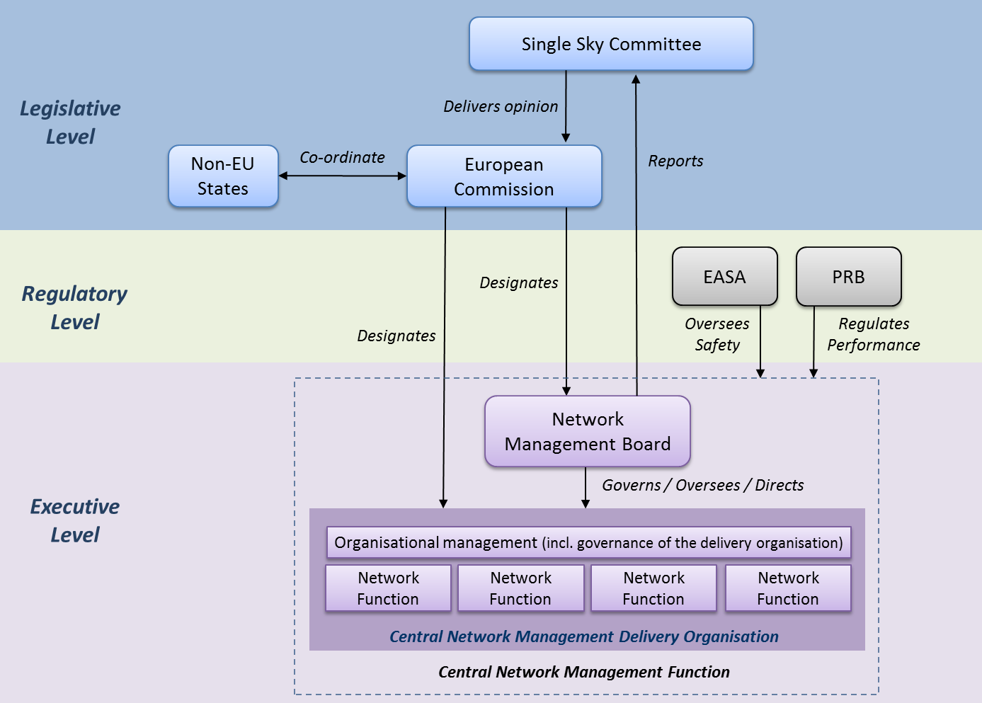

Organisation and management of Network functions
From 2020 onwards, the Network Functions (expanded in accordance with industry needs and subject to the EC designation) should continue to be performed within the SES legal framework, recognizing the role of States and incorporating the need for an increased role of industry (ANSPs, airlines, airports and other future operational stakeholders) in the governance and oversight of the activities of the Network Manager.
Key recommendations:
- The Network Manager should continue to be a regulated entity under the Performance and Charging Scheme, and subject to full economic oversight by the Commission and safety oversight by EASA.
- The Network Manager activities should be clearly defined in scope and nature according to the priorities of the SES Performance Scheme, and should not be treated as static.
- The Network Manager should be funded by a mechanism that is transparent (for example via a separate NM route charge) and does not cross subsidise the wider activities of any organisation that is nominated by the EC to perform the role of Network Manager. It should deliver services as an autonomous entity respecting the rules established in the Framework Regulation including work programme, budget, governance and financing.
- Options for the future NM could include the re-designation of EUROCONTROL, the establishment of a public private partnership with EUROCONTROL or an industrial partnership outside of EUROCONTROL.
The ICB’s vision for SES states a clear preference for “the Network Manager as an industrial partnership, under the governance of operational stakeholders”. An industrial partnership could be a multi-stakeholder organisation, with scope to involve the military, designed specifically for the purpose of executing Network Functions and with good links to Member States. It should not be built upon the same premise as other industrial partnerships – ie the Deployment Manager, which is specifically set up for the purpose of investment. The existing expertise within the Network Manager should not be overlooked – the key issues lie within the reorganisation of the governance.

Network crisis management
The role the EACCC has is an important one. There is no EU competence in crisis management, and the EU is not in a position to make decisions to tell Member States how they must react to crises in their airspace. The EACCC mechanism pools expertise together to work out a response to the crisis, which the Member States in question then delegates to a national ANSP or to the Network Manager to address. The Network Manager should continue to support EACCC.

Additional Network Functions
The ICB’s vision for SES states that the Network Manager should be responsible for the overall definition and design of the network, based on the European ATM Master Plan, ICAO GANP, SESAR solutions as well as inputs from the Deployment Manager, and operational stakeholders.
Additional Network Functions should be defined in relation to the definition of the network, along with the safety and operational accountabilities for stakeholders as this would define the level of Network Manager intervention required.
The ICB recommends that the re-designation of the Network Manager is a key opportunity to open discussions on additional Network Functions; it would disadvantage the new Network Manager not to be involved in these discussions.
Additional Network Functions could include [list provided by the Network Manager as a proposal for review and comment by the ISG]:
- Optimisation of ASM, DCB and resources;
- Optimisation of ATM/CNS infrastructure and services;
- Performance data repository;
- Aeronautical data as a common service;
- Node for Global ATFM to support better connectivity and performance;
- Development and validation of new concept of operations in SESAR to improve network performance.

barriers to change
In addition to the recommendations described above, special attention will need to be given to the following issues in order to optimise the performance of the European ATM network:

- Many ANSPs currently do not have sufficient freedom to operate innovatively and more collaboratively whilst meeting state obligations.
- The current Charging and Performance Scheme does not drive the right behaviours as it fails to provide the right balance between local, sub-regional and network performance.
- There has been a failure to enable a Service Orientated Architecture in a timely manner via SESAR deployment.
- State sovereignty has often been used as a blocker to change.
- There is a lack of confidence on the part of Member States to address liability and insurance issues associated with delegated airspace.
- There is a reluctance of Member States and ANSPs to extend cross-border service provision within the terms of existing regulation.
- The lack of suitable regulation and standardised training activities is a barrier to the optimisation of controller distribution to fill network capacity gaps.

conclusion
Optimising safety and performance across the European ATM network requires action by many stakeholders at different levels; the Network Manager and Network Functions are important aspects of this and will remain so.
When considering the future role of the Network Manager, the ICB considers it essential that safety and operational accountabilities are clearly defined in relation to other actors in the network and the level of intervention required. A network definition is a key basis for this, as well as for defining additional Network Functions.
For the efficient operation and evolution of the Network Manager, the ICB concludes that the priority should be in strengthening the governance arrangements – the Board should have clear responsibilities and accountabilities which allow appropriate control over the Network Manager. Airlines, airports and ANSPs need to have a key role in the governance, as their service delivery is dependent upon the services provided by the Network Manager.
The ICB’s vision for SES states a clear preference for “the Network Manager as an industrial partnership, under the governance of operational stakeholders”. The definition of an industrial partnership could be a multi-stakeholder organisation, designed specifically for the purpose of executing Network Functions and with good links to Member States – this will be further defined by the ICB in future work in 2016.

Note that work to define the network is underway, being led by the Commission and the Network Manager Board.

